Juan Andres Salas

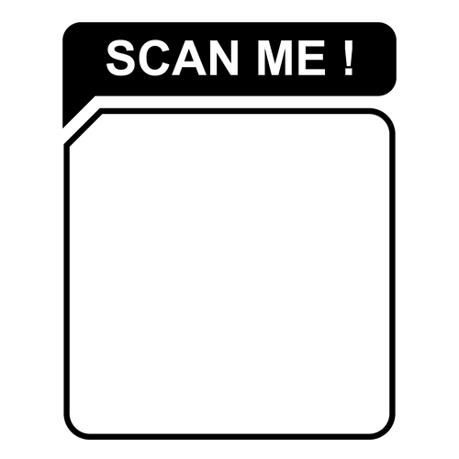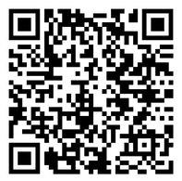

J r S o f t w a r e E n g i n e e r & M e c h a n i c a l E n g i n e e r

 [juandre1298@gmail.com](mailto:juandre1298@gmail.com) (+57) 300 734 02 78

[www.linkedin.com/in/juan-andres-salas](http://www.linkedin.com/in/juan-andres-salas) https://portfolio-juandretech.vercel.app/



<https://github.com/juandre1298>

Jr. Frontend Software Engineer and Mechanical Engineer. With skills in React Js | Next.js | Javascript | Typescript | HTML | CSS| TailWind | Responsive Design | React-toastify | Fire-Base | | Redux | Email js | Dynamic Routing | GIT | GITHUB

# Technical Projects

## Portafolio page

 [[https://portfolio-juandretech.vercel.app/](https://portfolio-juandretech.vercel.app/)]

Created an intuitive UI and responsive portfolio webpage using Next.js, React.js, TailwindCSS, Email.js, and other technologies.

Gained hands-on experience in front-end development, UI/UX design, JavaScript, state management, API integration, deployment.

## Awesome e-commerce

 [<https://awesome-shop-app.web.app/>]

Successfully built from scratch a fully functional e-commerce website using React JS, TailwindCSS, and Firebase and other technologies.

## Social Media webpage

 [<https://react-course-69a26.firebaseapp.com/>]

Successfully developed and deployed a TypeScript React app using Firebase for user authentication and deployment.

Gained valuable experience as a junior front-end developer with technologies such as Redux, API management, and react-router-dom.

Incorporation of TypeScript and Firebase contributed to a secure application, showcasing growing proficiency in front-end development.

# Work Experience

**Service Coordinator - DST S.A.S. January 2022 - August 2022**

Product and Project Management.

Conflict resolution and negotiation with companies and clients in Colombia, USA and Ecuador. Technical support in B2B and B2C.

**Quality Coordinator - Tecnoglass S.A.S. July 2021 - January 2022**

Planning and implementation for business development for continues growth projects. Design and execution of study cases.

Leading teams in order to guarantee Quality requirements. Control of quality and production KPIs and OKRs.

# Education & Soft Skills

**Mechanical Engineer** Universidad del Norte 2015 - 2020

**Language**

English: Advanced Spanish: Native

**Soft Skills** Problem solving Team work

Effective communication. Attention to detail.

**References**

Upon request